# **PART 1: Mnist Project Report**

**Shenhav Meshulam 313614273**

**Dana Eliyahu 313265332**

**Tom Mendelson 205949746**

### **1st Neural Network architecture:**

1. **Model architecture:**
   1. **Number of layers:** 3
   2. **Size of layers:** 784, 256, 10
2. **Learning rate:** 0.01
3. **Optimization algorithm:** Adam
4. **Loss function:** Softmax cross entropy with logits
5. **Batch size:** 200
6. **Amount of epochs:** 10
7. **Activation functions**:

1. relu

2. softmax

1. **Regularization/dropout:** Not used
2. **A plot of training loss and validation loss:**

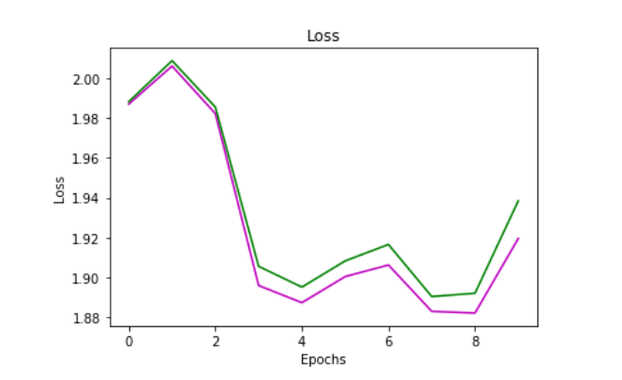

1. **A plot of training accuracy and validation accuracy:**

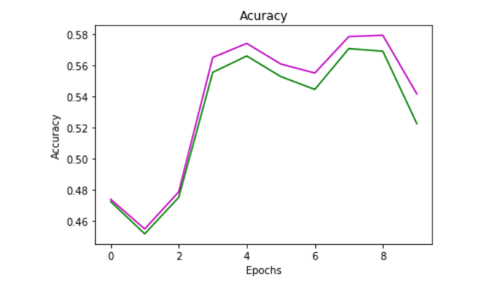

### **2nd Neural Network architecture:**

1. **Model architecture:**
   1. **Number of layers:** 3
   2. **Size of layers:** 784, 256, 10 (1 hidden layer)
2. **Learning rate:** 0.01
3. **Optimization algorithm:** Gradient Descent
4. **Loss function:** softmax cross entropy with logits
5. **Batch size:** 200
6. **Amount of epochs:** 20
7. **Activation functions:**

1. relu

2. softmax

1. **Regularization/dropout:** Not used
2. **A plot of training loss and validation loss:**

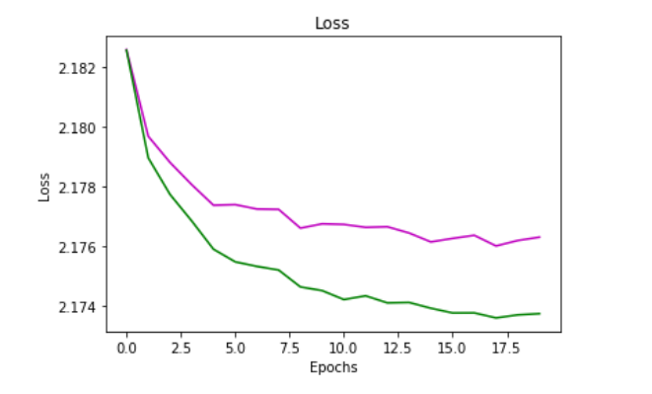

1. **A plot of training accuracy and validation accuracy:**

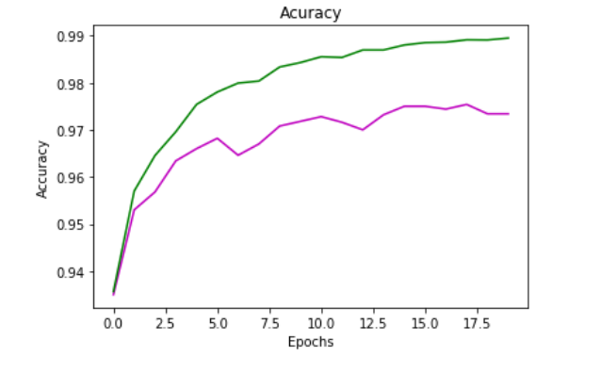

### **3rd Neural Network architecture:**

1. **Model architecture:**
   1. **Number of layers:** 4
   2. **Size of layers:** 784, 256, 128, 10
2. **Learning rate** **:**0.02
3. **Optimization algorithm:** Adam
4. **Loss function:** softmax cross entropy with logits
5. **Batch size:** 150
6. **Amount of epochs:** 20
7. **Activation functions:**

1. sigmoid

2. softmax

1. **Regularization/dropout**: 0.4 between the first hidden layer and the second hidden layer.
2. **A plot of training loss and validation loss:**

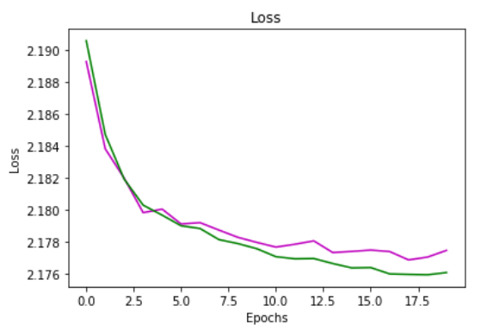

1. **A plot of training accuracy and validation accuracy:**

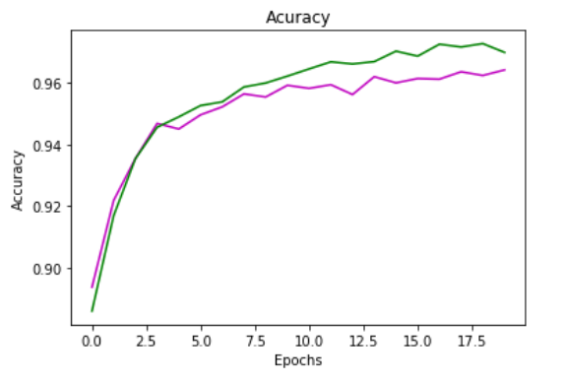

http://www.wikiwand.com/he/%D7%A8%D7%A9%D7%AA_%D7%A2%D7%A6%D7%91%D7%99%D7%AA_%D7%9E%D7%9C%D7%90%D7%9B%D7%95%D7%AA%D7%99%D7%AA#/%D7%AA%D7%94%D7%9C%D7%99%D7%9A_%22%D7%90%D7%99%D7%9E%D7%95%D7%9F%22_%D7%94%D7%A8%D7%A9%D7%AA